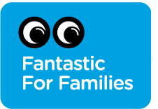
Awards 2019 entry form
Please complete this form and submit it with your supporting material (see p.8) to info@fantasticforfamilies.com. Important instructions on submitting your application can be found on the final page of this document.

DEADLINE FOR ENTRIES: 12pm Friday 7 December 2018
We will unfortunately be unable to consider entries past this deadline.

About the Awards
Previously the Family Arts Festival awards, the Fantastic for Families Awards recognise outstanding achievement in cultural provision for families across the UK
Who can apply
Applications are open to any cultural organisation or event organiser operating during January – November 2018. Entries will be judged by an expert panel drawn from the Family Arts Campaign Consortium. Awards will be presented as part of the 2019 Awards Ceremony on 11th February 2019 in Liverpool.

Awards will be given in the following categories. You can apply for more than one category if you wish.

 | Award | Description
1 | Best Family Event | This category focuses on the event itself including families’ overall enjoyment of the event and its suitability for family audiences of all ages.  NB: You can only submit one event per organisation for this category.
2 | Best Family Venue | This category focuses on the venue and includes suitability of the venue's facilities for a wide range of families’ needs. If your organisation is not a venue, you may nominate a venue you have worked with.
3 | Best Family Welcome | This category covers all areas of the visitor experience including staff welcome, communication, and the venue and its facilities to attract a diverse range of families. If you’re not a venue organisation, this category covers how you work with venues to create a smooth and positive experience and communicate relevant information to families.
4 | Best Age Friendly Welcome | A new category recognising outstanding provision for older visitors, including staff welcome, communication and the venue and its facilities in accommodating the needs of older people. If you’re not a venue organisation, this category covers how you work with venues to create a smooth and positive experience and communicate relevant information to older visitors.
5 | Audience Choice Award | Decided via public vote, you do not need to submit an application to be eligible to win the Audience Choice Award. Simply send families to your organisation profile on fantasticforfamilies.com to vote for you. Audience Choice voting will run until 28th January 2019, giving you more time to collect valuable feedback from families. More information here.  NB: to be eligible for the Audience Choice Award, your organisation must have first signed up to the Family Arts Standards.
Application Form
Organisation
Address
Lead contact name & job title

Tel
Email
Website
Account name/handle | Twitter ☐  _________ | Facebook ☐  _________ | YouTube ☐  _________ | Instagram ☐  _________ | Other ☐  _________

About your organisation: brief overview of your organisation and your family-friendly offer (200 words max):

Award Category:
Which category/s are you applying for? (please tick)

☐ Best Family Event page 3
☐ Best Family Venue page 4
☐ Best Family Welcome page 5
☐ Best Age-Friendly Welcome page 6

Best Family Event

Event name:

Was this event listed on fantasticforfamilies.com?

Please list all collaborating organisations and how they were involved in the event e.g. producer, performing company, etc. (100 words max.)

In no more than 400 words, tell us why you think your event should win the Best Family Event award.
Please include the following information:  - Brief overview of the event i.e. artform/format/duration/content  - The audience you hoped to reach  - How many people you reached and feedback  - Outcome/ impact on participants and your organisation | JUDGING CRITERIA:  - Genuine appeal and suitability for different age groups attending or participating together  - Evidence of innovation in engaging families  - Content engages a broad range of families or the particular segment it aims to engage  - Content inspires families to engage further in cultural activities  - Outcomes and impact are clear both for families  and for organisation

Best Family Venue
Venue name:

Is this venue signed up to the Family Arts Standards? | ☐ Yes  ☐ No

In no more than 400 words, tell us why you think your event should win the Best Family Venue award.

Please include the following information:  - Size of venue/ capacity  - Any specific facilities which are useful to families  - How accessibility and facilities are communicated to families  - How the venue has impacted both your organisation and family audiences | JUDGING CRITERIA  Practical considerations listed in the Family Arts Standards are met and exceeded:  - Venue takes a systematic approach to understanding the needs of families  - Venue has clearly taken extra care to ensure facilities meet the needs of families  - Venue has taken care to provide practical information for families in advance  - Venue engages with a range of families that reflect its catchment area  - Venue has taken steps to improve quality of experience for families

Venue Contact (if different):
Name: _________________________________
Email: __________________________________
Best Family Welcome
Organisation name:

Is the organisation signed up to the Family Arts Standards? | ☐ Yes  ☐ No

In no more than 400 words, tell us why you think your organisation should win the Best Family Welcome award.

Please include the following information:  - How your organisation provides an exemplary welcome to a broad range of families across your programme, staff welcome, communication and facilities (if applicable)  - What changes and/or impact you think your welcome to families has made | JUDGING CRITERIA  - An exceptional customer journey is provided from start (advance information available prior to families deciding to attend) to finish (post-event engagement with families is encouraged)  - Needs of families making their first visit are specifically addressed  - Families are targeted or encouraged to engage in a particularly innovative or effective way  - The organisation has gone to great lengths to welcome families with a wide range of needs  - Welcome has created increased quality of experiences for families

Best Age-Friendly Welcome
Organisation name:

Is the organisation signed up to the Age Friendly Standards? | ☐ Yes  ☐ No

In no more than 400 words, tell us why you think your organisation should win the Best Age-Friendly Welcome award.

Please include the following information:  - How your organisation provides an exemplary welcome to older people across your programme, staff welcome, communication and facilities (if applicable)  - What changes and or impact you think your welcome to older audiences has made | JUDGING CRITERIA:  - An exceptional customer journey for older visitors is provided from start to finish  - The range of needs that older people may have is understood and accommodated by your organisation and staff, facilities that welcome older people and mitigate/ provide information on any factors which may present barriers to engagement (if your organisation is not a venue, please describe how these considerations are applied to the venues you work with)  - Your programming is considered with suitability for a wide spectrum of age groups in mind  - Older people are targeted or encouraged to engage in a particularly innovative or effective way  - Welcome has created increased quality of experiences for older audiences

Supporting materials
Please provide us with a limited amount of supporting material that will directly support the application by attaching with your email application or providing links below. Please indicate below what supporting materials you wish to submit.
Please note that by supplying supporting materials you are giving Family Arts Campaign permission to use them within the Fantastic for Families marketing campaign and other Campaign communications.
*Please limit to a maximum of 3 items per category below, and ensure all materials are clearly labelled with your application name and any photo credits.
Logo
Photographs (hi res)
Marketing flyers/ posters
Video links
Press clippings
Participant feedback/surveys
OTHER
Save the Date: 11th & 12th February 2019
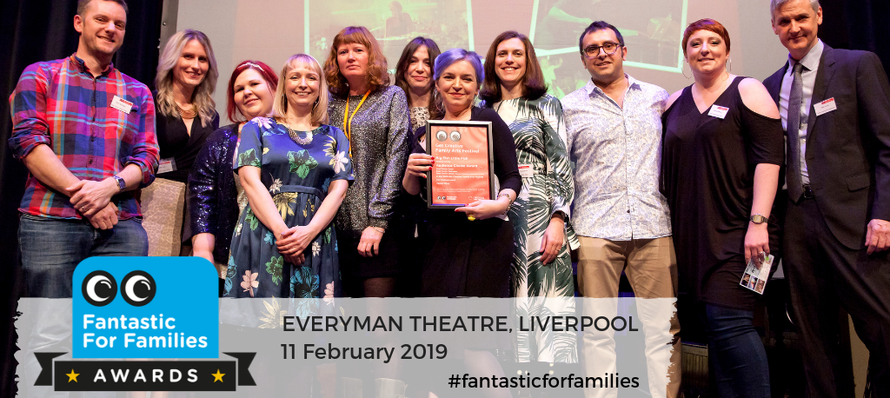
Winners will be announced at a ceremony on 11th February in at the Everyman Theatre in Liverpool. All organisations who submit an application are welcome to attend for free, subject to available places. Book your place
You may also wish to stay in Liverpool to attend the national Family Arts Conference on 12th February 2019 (also in the Everyman Theatre). Tickets can be booked here.
Notes on completing and submitting your application
The application
You may apply for multiple award categories.
You may only submit one entry per category.

For further information to help you with your application, applicants are advised to review our guidance in the Family Arts Standards and Age Friendly Standards.

If you are a company applying for a Best Family Event or Best Family Welcome Award, you may nominate the Venue you have worked with for the Best Family Venue Award.

Submitting your application
Please submit your application form and supporting material to info@fantasticforfamilies.com. By 12pm Friday 7th December 2018. We will unfortunately be unable to consider entries past this deadline.
When submitting your application, please state which categories you are applying for in the body of the email.
Sending your supporting materials
Please note that emails with large attachments may bounce. We recommend limiting your attachments to 20MB or less. Once received, we will confirm receipt of your application via email.
When transferring documents via sites such as WeTransfer, please include the download link within the application, rather than in a separate email. If there is an expiry date on the attachment, please state this clearly in the body of the email along with the download link.
If sharing documents via GoogleDrive, Dropbox or similar, please ensure that they remain available to access throughout the judging period.
When we will contact you
Shortlisted organisations will be contacted by 21st December 2018 and will be asked to confirm attendance at the Fantastic for Families Awards Ceremony on 11th February 2019 in Liverpool. Please add this date to your diaries.
The Audience Choice award winner will be contacted by 31st January 2019.

Best of luck for your application!

