Awards 2016 entry form
Please complete this form and submit it with your supporting material to awards@familyartsfestival.com.

DEADLINE FOR ENTRIES: 5pm Wednesday 30 November 2016

About the Awards
Now in their fourth year, the Get Creative Family Arts Festival Awards recognise outstanding achievement in family arts activity across the UK, which culminates annually in October’s Festival.

Awards will be given in five categories:

 | Award | Description
1 | Best Family Event | This category focuses on the event itself including families’ overall enjoyment of the event and its suitability for a family audience.
2 | Best Family Venue | This category focuses on the venue and includes suitability of the venue's facilities as well as quality of advance venue information for families. If your organisation is not a venue, you may nominate the venue you worked with.
3 | Best Family Welcome | This category covers all areas of the visitor experience including the event itself and the venue and its facilities. If you’re not a venue organisation, this category covers how you worked with your venue to create a smooth experience and communicate relevant information to families.
4 | Best Event for Older People and Families | A new category for excellence in engaging older people as part of the family experience.
5 | Best Family-Friendly Workplace | A new category that recognises arts organisations who embed family-friendly practice in their workplace and excel in providing for employees with caring responsibilities.

You may apply for multiple award categories. Entries will be judged by an expert family arts panel. Categories 1-3 will also have an Audience Choice award, so make sure to send families to your listing on familyartsfestival.com to rate your event and leave feedback. Please direct families to your listing on the Festival website or the landing page familyartsfestival.com/rate.

To apply for a Festival Award, please complete and return the below application form, along with supporting material.
Application Form
Contact details:

Organisation
Address
Lead contact name & job title

Tel
Email
Website
Account name/handle | Twitter ☐  _________ | Facebook ☐  _________ | YouTube ☐  _________ | Instagram ☐  _________ | Other ☐  _________

About your organisation: brief overview of your organisation and your family-friendly offer (200 words max):

Award Category:
Which category/s are you applying for? (please tick)

☐ Best Family Event
☐ Best Family Venue
☐ Best Family Welcome
☐ Best Event for Older People and Families
☐ Best Family-Friendly Workforce
Best Family Event

Please describe below the event you are nominating (300 words max). Please include the following information:

- Brief overview of the event and its objectives
- Artform(s)
- Activities (performances/ workshops…)
- Audiences
- Duration
- Participation stats from the Get Creative Family Arts festival
- Outcome/ impact on participants

JUDGING CRITERIA:
- Events should genuinely appeal to and be suitable for an under-16 and an over-16 attending or participating together
- Artistic approach demonstrates development and news ways of working in your organisation
- Evidence of innovation in engaging families
- Content engages a wide range of families or the particular segment it aims to engage
- Content inspires families to engage further with the arts

Event name:

Listing URL on familyartsfestival.com | http//www.familyartsfestival.com/event/____

Was this event commissioned for the GCFAF? | Yes/ No

Please list all collaborating organisations and how they were involved in the event e.g. producer, performing company, etc.

Further information:

Best Family Venue
Please describe below the venue you are nominating (300 words max). Please include the following information:

- Size of venue/ capacity
- Any specific facilities which are useful to families
- How accessibility and facilities are communicated to families

JUDGING CRITERIA
- Practical considerations listed in the Family Arts Standards (see page 11-12) are met and exceeded
- Venue takes a systematic approach to understanding the needs of families
- Venue has clearly taken extra care to ensure facilities meet the needs of families
- Venue has taken care to provide practical information for families in advance
- Venue engages with a range of families that reflect its catchment area

Venue name:

Further information:

Venue Contact (if different):
_________________________________

Best Family Welcome
Please describe below the customer service provision you are nominating for this award (300 words max). Please include the following information:

- Employee numbers (paid/ volunteers)
- Training/ development offered to staff to welcome families
- How you used your involvement in the Festival to extend your welcome to families

JUDGING CRITERIA
- An exceptional customer journey is provided from start (advance information available prior to families deciding to attend) to finish (post-event engagement with families is encouraged) (see Family Arts Standards on pages 11-12)
- Needs of families making their first visit are specifically addressed
- Welcome given to families is tailored to meet the diverse needs of different families
- Families are targeted or encouraged to try something new in a particularly innovative way
- The organisation has gone to great lengths to welcome families with additional access needs

Further information:

Best Event for Older People and Families
Please describe below the event you are nominating (300 words max). Please include the following information:

- Brief overview of the event and its objectives
- Artform(s)
- Activities (performances/ workshops…)
- Audience make-up by age group
- Duration
- Participation stats from the Get Creative Family Arts festival
- Outcome/ impact on participants both young and old

JUDGING CRITERIA:
- Events should genuinely appeal to and be suitable for older people attending or participating together with their families
- Artistic approach demonstrates development and news ways of working in your organisation to engage/include older family members
- Evidence of innovation in engaging older generations
- Content inspires families, including older members to engage further with the arts

Event name:

Listing URL on familyartsfestival.com | http//www.familyartsfestival.com/event/____

Was this event commissioned for the GCFAF? | Yes/ No

Please list all collaborating organisations and how they were involved in the event e.g. producer, performing company, etc.

Further information:

Best Family-Friendly Workplace Initiative
Please describe below how your organisation has made itself more inclusive to support workers with parental and other caring responsibilities (300 words max). Please include the following information:

- The issue you were trying to address
- The actions you took/are taking
- What you perceive as the impact from your intervention
- Feedback from parents and other carers

JUDGING CRITERIA- We are looking for examples of:
- Identification at a senior management level of issues for parents and other workers with caring responsibilities in the workplace
- Innovative good practice in provision made for employees who have caring responsibilities
- Management perception of improved provision for workers with caring responsibilities
- Testimony from affected workers to support this

Further information:

Supporting materials
Please provide us with a limited amount of supporting material that will directly support the application by attaching with your email application or providing links below. Please indicate below what supporting materials you wish to submit.
*Please ensure all materials are clearly labelled with your application name
Logo
Photographs (5 max, hi res)
Marketing flyers/ posters
Video links
Press clippings
Participant feedback/surveys
OTHER

Please note that in order to be considered for an award you must complete the Get Creative Family Arts Festival evaluation survey:
- Show 1 piece of evidence of using the Get Creative Family Arts Festival branding in your event marketing. This could be our logo on your print, use of free Festival posters, flyers and stickers, or logo on your website, in an e-marketing campaign or in your social media activity.
- Complete a short one-page Festival evaluation survey which we’ll send to you in November 2016.
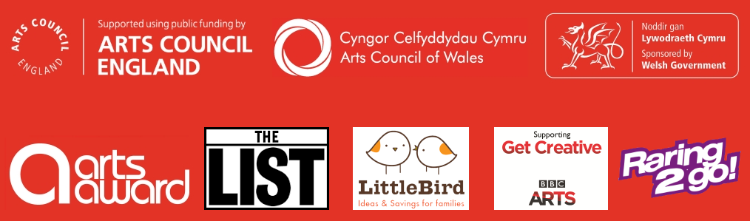
Winners will be contacted by 31 January 2017 and will be announced at a ceremony in the spring.
