Thanks for joining us at our Family Arts Festival event – we hope you enjoyed it!
Let us know what you thought by rating our event and you will be entered into a prize draw to win an iPad mini!
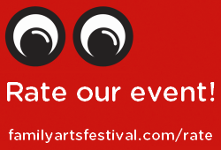
Want to continue the fun? Sign up to our mailing list to hear about more events in your area, and have a go on the Family Arts Festival portrait app!
Thank you,
The Family Arts Festival team.
www.familyartsfestival.com

